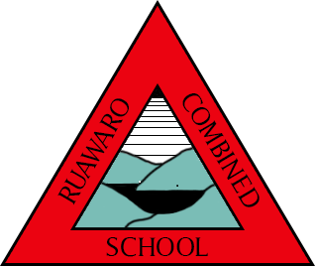

Ruawaro Combined School

Information Booklet
2022

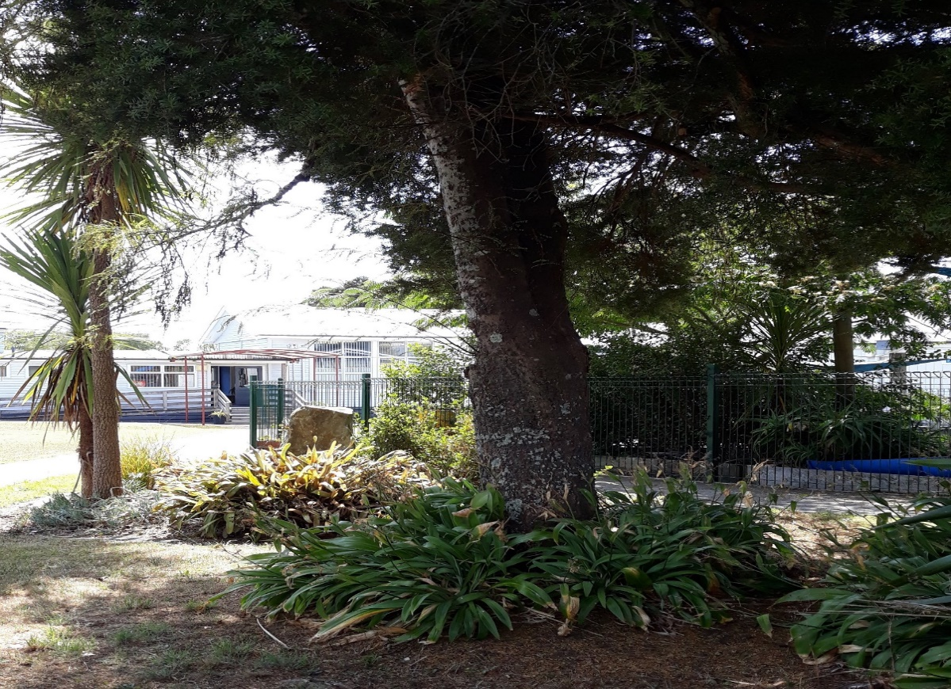

Kia Ngatahi ki ako - Learning together-

Ruawaro combined school 2022

76 Bain Rd RD2 Phone: 07 826 6706
Huntly, 3772
Mobile: 0274266706
Email: admin@ruawaro.school.nz
Website: www.ruawaro.school.nz

ruawaro combined school STAFF

Principal Sue Ewen principal@ruawaro.school.nz

Teachers Karyn McInally Years 5-8(Whare Karearea))

Jessica Brannagan Years 2-4 (Whare Kereru)

Nikita Turner Years 1-2 (Whare Kea )

Joanne Briggs Learning Support

Teacher Aide Paula Hardwick, Karin Smith

Administration Karen Mills

Office Phone Number: 078266706

BOARD OF TRUSTEES
Meets twice a term ( Dates TBA)

Chairperson Carley Jones

Members Ryan Hardwick
Gareth Roberts

Staff Trustee Karyn McInally
Principal Sue Ewen

Mail for B.O.T. can be sent C/- Ruawaro Combined School
76 Bain Road RD2, Huntly, 3772.
admin@ruawaro.school.nz

SCHOOL INFORMATION 2022

Term Dates 2022

Term 1 01 February – 14 April
Term 2 02 May – 08 July
TOD – Friday 3rd June
Term 3 25 July – 30 September
TOD – Friday 29th July ( Parent /Teacher conferences)

Term 4 17 October – 14 December

Public Holidays 2022

07 Feb - Waitangi Day (Monday)
15 Apr – Good Friday
18 Apr – Easter Monday
19 April - Easter Tuesday
25 Apr – ANZAC Day ( Monday in School Holidays)
06 June – Queen’s Birthday (Monday)
24 June - Matariki
24 Oct – Labour Day (Monday)

Cluster Events 2022

04 Mar – Senior Swimming (Yr 4-8) – Glen Massey School (Cancelled)

11 Mar – Junior Games (Yr1-3) – Ruawaro Combined School (Cancelled)

20 May – Senior Winter Games (Yr 4-8) –Te Akau Complex

01 July – Arts Festival (whole school) – Te Akau Complex

05 Aug – Senior Gym Day (Yr 4-8) – Huntly Gym Club

12 Aug – Cross Country (whole school) – Waikaretu School

08 Sept – Senior Speeches (Yr 5-8) – Waingaro School

18 November – Senior Athletics (Yr 4-8) – Glen Massey

School Hours:

School begins: 9.00 am
Interval: 11.00 am – 11.30 am
Lunch Break: 1.00 pm - 1.45 pm
School Ends: 3.00 pm
The school does NOT close early on wet days.

School hours may alter under special circumstances (Start and finish times will remain the same)

School Donations
The school does not ask for donations as the BOT has opted into the Ministry of Edcuation Donations Scheme. Parents may be asked to fund direct costs for consumables.

Absence Notification
All absences from school should be notified by a note prior to the absence to the classroom teacher or through a phone call to the office. Alternatively, you may send a ClassDojo message to your child’s classroom Teacher or a text to 027 4266706 (no voice messages please) or use the Skool Loop App, before 9.00am. The school will contact home for an explanation of an absence if not notified in advance.
If you wish to take your child away during term time, you must inform the Principal.

Bus
All children travelling by bus are checked on by the duty teacher, and children on the last bus will be supervised until their bus arrives.
Please advise the school office or classroom teacher if children are not travelling home in the usual way (i.e. being picked up or going home with someone else).
Please contact the office for times and routes.

If you are at the end of a run and your children are not travelling on the morning bus trip, please inform Go-Bus by telephone: 07 828 7037.

Stationery
All stationery requirements are available at the school and your child will be issued with a book list on arrival. You are welcome to purchase through school or other sources but please be sure to purchase the same brand/type of book on the stationery list to ensure all students have the same books. Stationery will be issued on payment of goods.

New Enrolments
Parents enrolling a 5 year old for the first time are required to present a Birth Certificate and Immunisation Record. All enrolments are done through the office. Ruawaro Combined School encourages prospective pupils to make at least two or three visits prior to their 5th birthday, so that they can become familiar with the School environment, teachers, pupils and school routines. Times for these visits can be arranged by contacting the school office.

Book Club
Children have the opportunity to buy good books at a reasonable price through the Scholastic Book Club. This offer is available twice a term and a catalogue will be sent home with each child. There is no obligation to buy. Please send order forms and money in named envelopes. You may also purchase via the Scholastic website using a credit card – all orders will be delivered to school. Books will be distributed 1-2 weeks from placement of order.
Duffy Books
Ruawaro Combined School is a Duffy School and thanks to the school and Duffy sponsorship we are able to provide books to go home 2 or 3 times a year. The Duffy programme also provides speakers and a theatre group visit to promote and encourage students to read,

COMMUNICATION
The school will keep you informed and updated on all school activities via Newsletters, Class Dojo, Skool Loop, our school website. Your child’s Teacher can assist you in accessing these.

Open Door Policy
We welcome parents at school at all times and plan for your active involvement in our programmes wherever possible.
Early in Term 1 there will be an opportunity to meet with your child’s teacher and set learning goals for the coming year.
Regular functions are organised where parents are invited to the school e.g. school productions, book displays, speech competitions, sports days, end of term celebration of learning assemblies, fundraising ventures, Calf Club, etc.
Meetings are also held periodically on specific topics e.g. curriculum subjects and how they are taught, and how families may assist their child/ren.

If you wish to discuss aspects of your child’s progress with your child’s teacher it is advisable to call in or contact them via phone or Dojo message and arrange a suitable time when they are free of classroom responsibilities. Please contact the school (classroom teacher in the first instance) if you have any concerns regarding your child/ren.
Procedures to follow if you have a concern of a serious nature (as contained in the school’s complaints policy).

- Ring the school and arrange a suitable time to speak with the class
teacher.
2. If you are still not satisfied, arrange a meeting with the Principal.
3. If you are still not happy, write to the B.O.T. A copy must be given to the Principal. The matter will be discussed at the next meeting.

Medical Information and Family Matters
Please notify us if your child has a health condition or if there is a family situation we should know about. A medical form must be completed yearly. Confidentiality is maintained at your request. If your child requires medication to be kept at school, please label carefully with instructions.

Technology Programmes.

Specialist Technology Programmes for Years 7 and 8 are provided at Huntly Primary School to which our senior children are transported fortnightly. There is an annual fee to cover materials which will be included on your child’s stationery list.

Programmes taken are:
Woodwork, Sewing, Cooking, Robotics, Photography

Lessons are held every 2nd Tuesday morning and children are bused to and from the Centre leaving school at 8:45am and returning by 1:00pm. For Health and Safety reasons, children are required to wear fully enclosed shoes for Technology. Students who do not have the required footwear will remain at Ruawaro Combined School for the morning.
In 2021 the first day of Technology will Tuesday 16th February.

School Uniform
The school uniform, which all children are required to wear, consists of a t-shirt (short sleeve) and for colder weather a polar fleece vest and a polar fleece long sleeved jacket. These items can be purchased through school. Please contact the office for a price list
The remainder of our uniform items which consist of black (or navy) pants, shorts or skorts will need to be purchased by parents as we do not source these from our supplier.
At various times there may also be some second-hand items available for purchase – please ask.
For safety reasons, we discourage the wearing of jewellery. Students with pierced ears are asked to only wear stud type earrings and long hair is to be tied up. A copy of our uniform policy is available at the school office.

Sunhats: All students are required to wear a sunhat in Terms 1 and 4. Information will be available at the start of each term.

Zero Waste

We are a Zero Waste School and as such encourage students to be aware of their responsibilities around “rubbish” disposal. We recycle paper and cardboard for which we get credits for trees through the Paper for Trees Scheme.
As a ‘zero waste’ school, we encourage students to bring all food items in washable or reusable containers to cut down on paper and plastic waste. Compostable food scraps will be collected, yoghurt pots recycled. All other food wrappings are to be taken home.

Weetbix in Schools. ( From Term 2)

Thanks to Sanitarium and Fonterra, we are able to provide weetbix and milk for any students who ask for it. If you do not want your child to participate please let us know. You may wish to choose to provide your child/children with alternative milk and/or cereal options (which can be kept at school) due to dietary requirements.

Personal Property
The Board of Trustees and staff accept no responsibility in the case of loss or damage to valuables or articles brought to school. While all reasonable care is taken and efforts made to find lost property, the responsibility rests with the owner. We prefer children to keep small toys and playthings at home - many are alike, they are difficult to name, can be easily lost and may be a distraction to others.

School Lunches
Children are encouraged to eat their lunches and are given time each day to do this.
As we are a ‘Zero Waste’ school we encourage children to bring food items in plastic reusable containers to cut down on paper and plastic waste. Any unfinished lunch and food wrappings are to be taken home (food scraps can be placed in the pig container we have at school) and yoghurt pots can be left at school to be recycled.

The following lunch items are available daily for purchase (subject to availability).

Pies  Mince & Cheese, Steak, Potato Top, Bacon & Egg | $3:00
Sausage Roll | $2:00
Cookies (2 small cookies) | 50c
Popcorn | $1.00
Fruit Cup | $1.00

Orders are taken before school. Please send your child’s order in a named envelope listing what they wish to order. In summer we encourage children with perishable items in their lunch to store them in the fridge.

Payments to school.
You are able to make any payments to the school using Online banking into the school account: 12- 3454-0066614-00
Or alternatively cash payments and Eftpos is available through the school office.

Education Outside the Classroom

As part of the school programme, day visits, camps, or sports days are undertaken by the school throughout the year. These are a valuable extension of the school curriculum. Parent help on such excursions is essential and any offers of transport or supervision at these times are greatly appreciated.
Parents will be notified of any events well beforehand so please check carefully for notices regarding these as they will contain important information and organisation details.

Our Vision:

Cooperation, Commitment, Growth

Mission Statement:

Kia Ngatahi ki ako - Learning together-

At Ruawaro Combined School we are committed to supporting and empowering:

Confident, lifelong learners who can problem solve independently and collaboratively.

Notes:

